I tried <local> value for ratl_mastership keyword, but query didn’t produced any output:

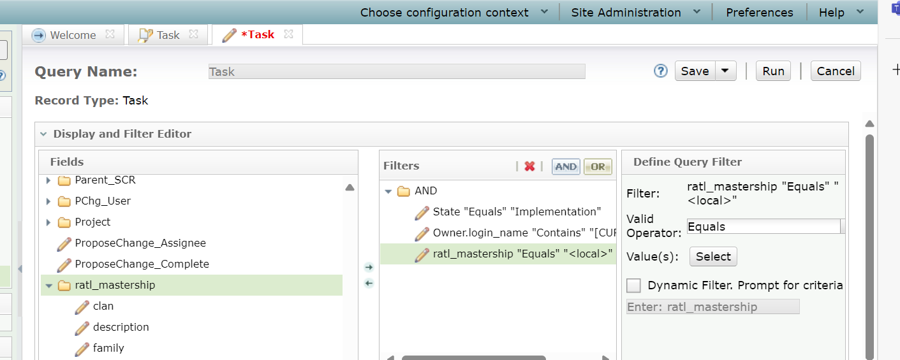

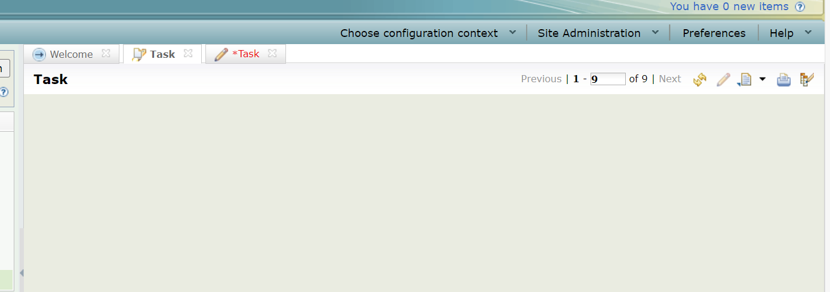

But when I select the site specific name as shown below, I am getting required output as shown below:

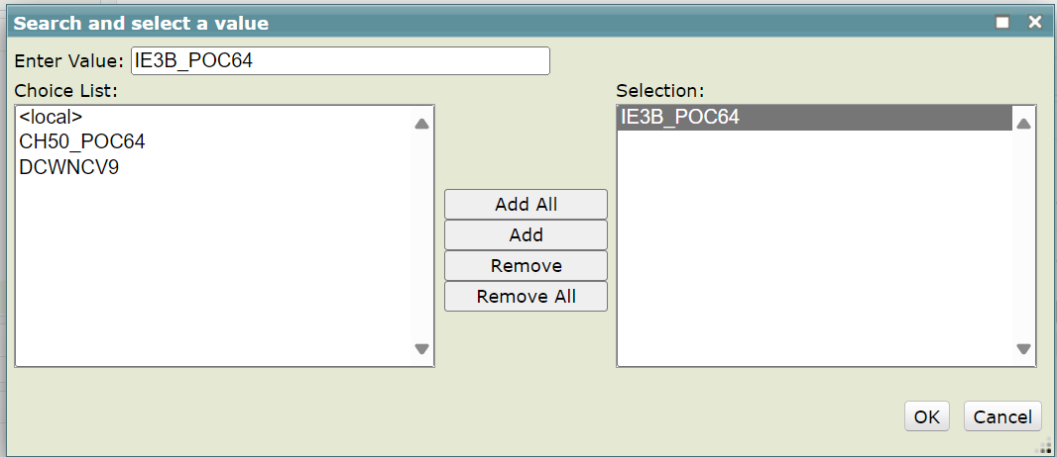

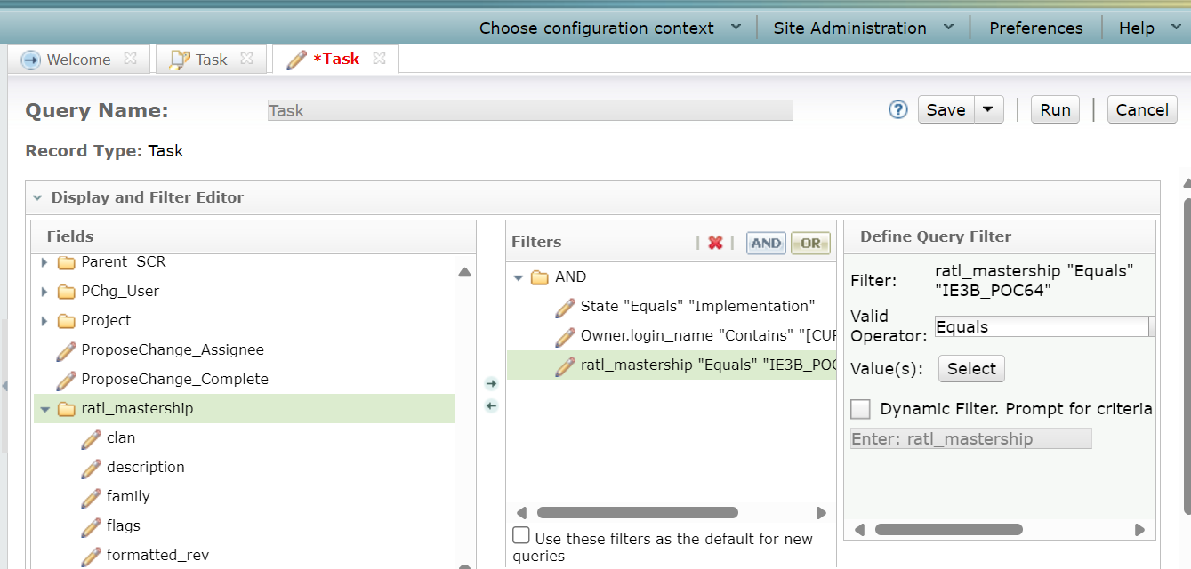

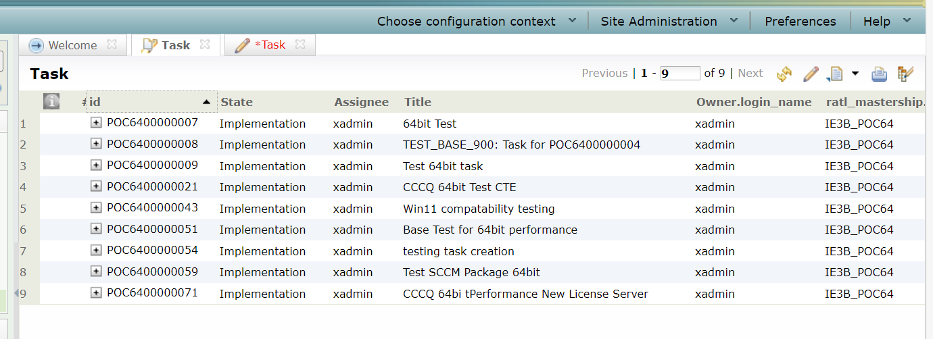

But, this is not meeting my requirement for multisite, as the value is hardcoded in Master site, im not getting required output in other site like DCWNCV9.

I am using one variable for fetching records of owner, for example if abc logged in to CQ and when he tries to fetch records of his own and which are in Implementation state I am able to do using below filters:

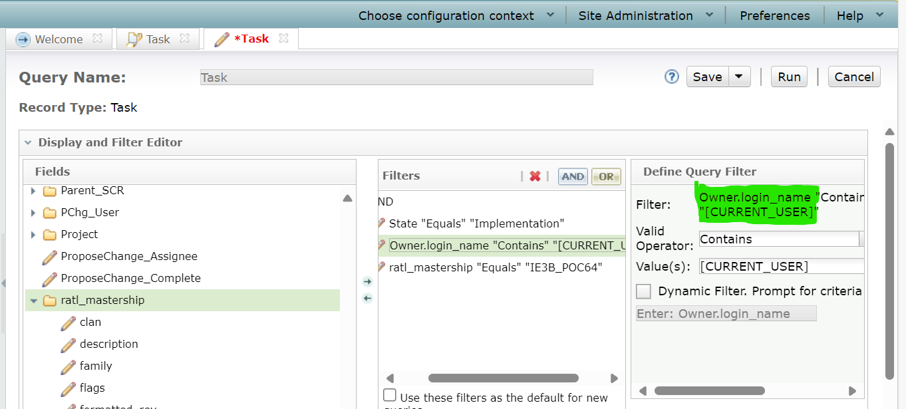

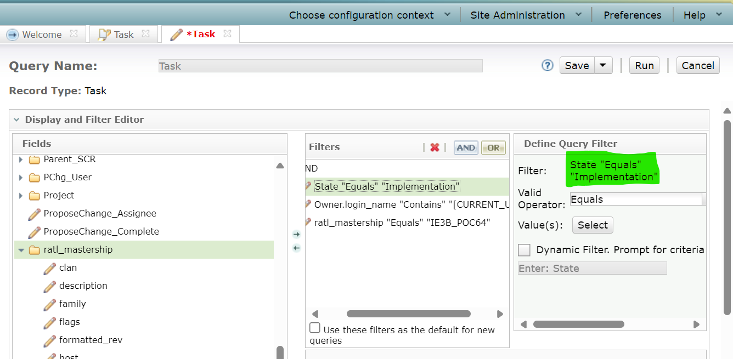

On similar lines, I need keyword and value for the filter which helps me in getting only locally mastered records.