Link Type | Link Ex. | Result when not logged in | Expected result met?
Community | https://dsam.deloitteresources.com/ram/community/overview.faces?gid=1743 | 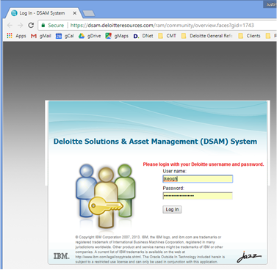 | Yes
Search | https://dsam.deloitteresources.com/ram/search/_rlvid.jsp.faces?_rap=_rlnn&_rvip=/search/index.jsp&n=1fGroup%2Csap_industrialized_assets%24fState%2Cpublished%24Classification%2Cclassif%2Fia_delivery_tool.xmi%23%2F%24industrialized_assets_delivery_tool%2Cid_81204&txt=config | 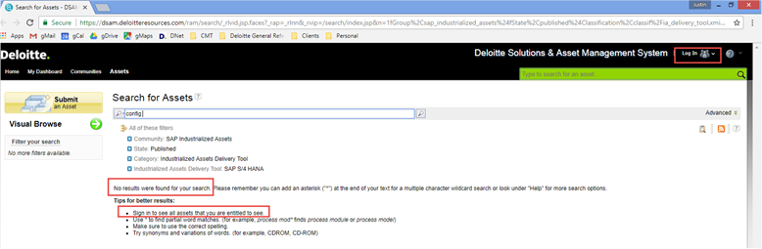 | No
Asset | https://dsam.deloitteresources.com/ram/oslc/assets/20993E4C-8B21-12F3-B28B-9D6915B888D2 | 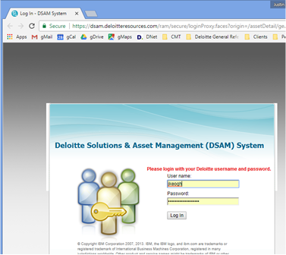 | Yes

