on the behalf of the Global AM Process team (and admin team for the Asset Management community in pRAM) I would like to approach you in regards of an issue in pRAM we face.
In pRAM there are more options for adding reviewers (or approvers):

A. in draft status using the button "add reviewers" at the top of the page (which takes you to the "Edit Lifecycle configuration" section)

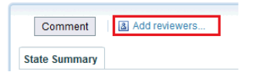
B. in any status going through the menu Review to Edit Lifecycle configuration and there using the button "Add reviewers"

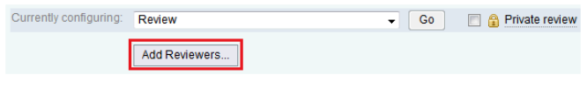

- managing reviewers using the Modify option



We know that reviewers (or approvers) should be always added only by using the option C (Modify), because if added with one of the other options, it causes various issues (names are disappearing...)
Nevertheless, there are still the buttons for it!

So our questions are:
1. Why are there the buttons (see option A and B) available? Is there a specific reason why the buttons are there if they don´t work correctly?
2. If there is no specific reason for the buttons to be there, would it be possible to remove them?

We register multiple troubles which it causes to the pRAM users, because, once they see the buttons, they use them for adding reviewers (or approvers) and later they face various issues caused by it. That´s why we would need this case to be better investigated and amended.

