Usecase 11 – RTWW - Copying script from one test to another do not copy the application
Type : usability
Scenario:
In the example I am trying to move the second part of the script as a separate script with an intention to make it as modular scripts.
- I create a new script of type “ New test”
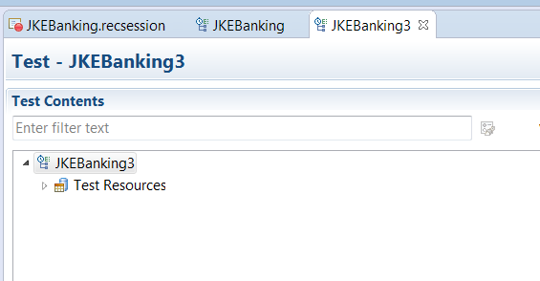
- I cut the module with comments and the application name . paste it to JKEBanking3,
How ever RTWW does not allow me to copy the content.

- To copy the content I need to first create an application
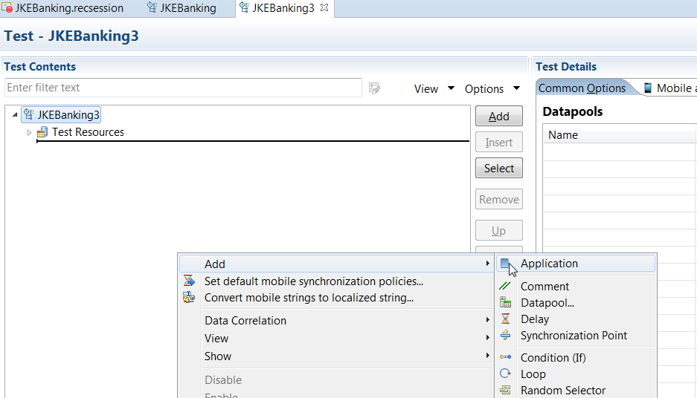
4.
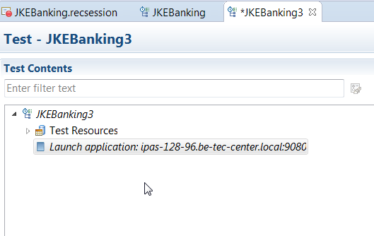
- Then copy the module into the script,
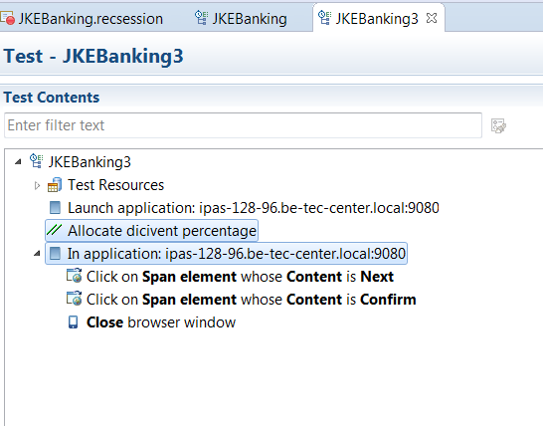
Will it be possible to automatically create the application ,during the process of copying the script.

