Use case 6: RTWW - “Test Dependency” of RTWW project

Type : usability

Scenario :

Following fields are always empty, is there a way where user can see some data / use these fields ?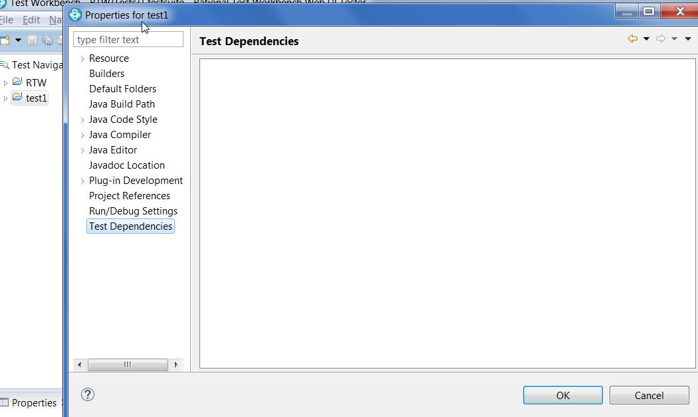

Linked resources

